|  |
| --- |
| **STUDENT NAME** |
| Alley Chaggar |

**LAB #2**

ACTIVITY 1 2

ACTIVITY 2 8

ACTIVITY 3 13

ACTIVITY 4 16

ACTIVITY 5 18

ACTIVITY 6 21

# ACTIVITY 1

## TILED OVERVIEW

This activity demonstrates how to create a simple map using the Tiled utility. Tiled is a free tool to easily create maps and levels.

Follow the steps below:

1. Download the Tileset1.rar file from E-Centennial and unzip to a folder.
2. Double–click on the Tiled icon on your desktop.
3. Click on the **New Map** button.
4. Set the options as shown below:   
     
   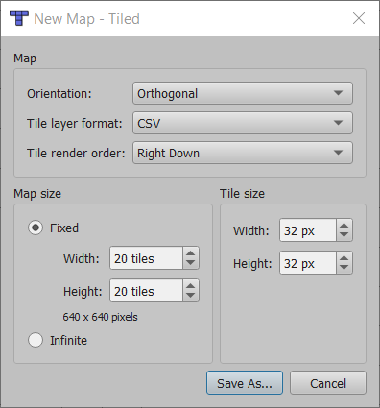
5. At the bottom - right of the screen click on the **New Tileset** button.
6. Set the options as shown below  
     
   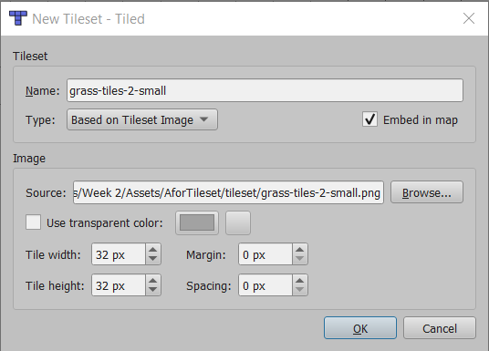
7. At the Source: set the path to the extracted file **grass-tiles-2-small.png** from the Tileset1.rar.
8. Click OK.

Once you complete the previous steps:

|  |
| --- |
| **TASK 1.1:**  Take a screenshot of the Tiled screen and paste it below: |
|  |

1. At the tileset pick a few tiles by clicking and dragging as shown below:  
     
   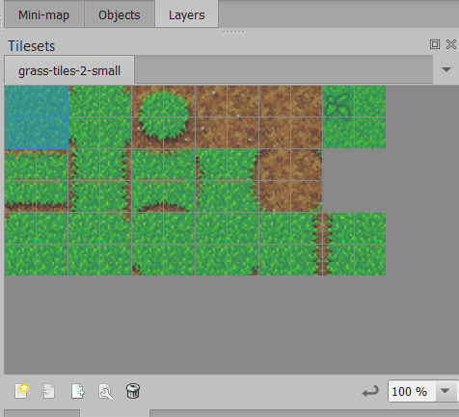
2. Return to the map main screen and draw something such as the map below (or any other map):  
     
   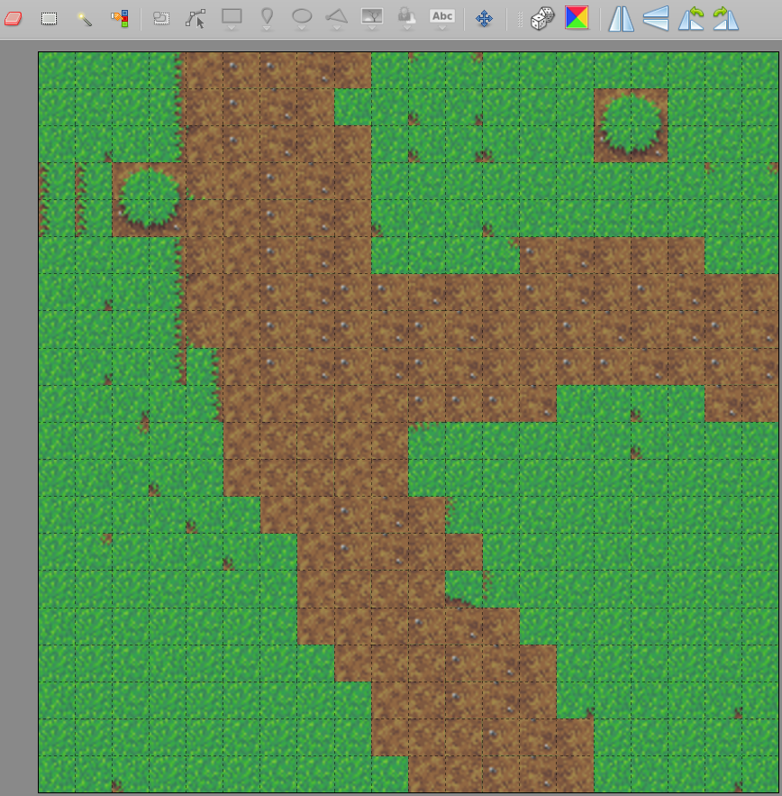

Once you complete the previous steps:

|  |
| --- |
| **TASK 1.2:**  Take a screenshot of the Tiled screen and paste it below: |
|  |

# ACTIVITY 2

## ADDING FOREGROUND AND BACKGROUND OBJECTS

This activity demonstrates how to add foreground object in a map. We are going to add a part of a tree because, when we have this map in our game, we would want our character to appear behind the tree when it walks past, so we will need to give the tree leaves some property to tell your game to render it over the character.

Follow the steps below:

1. Under the tileset click on the New Tileset button.
2. Set the options as shown below:  
     
   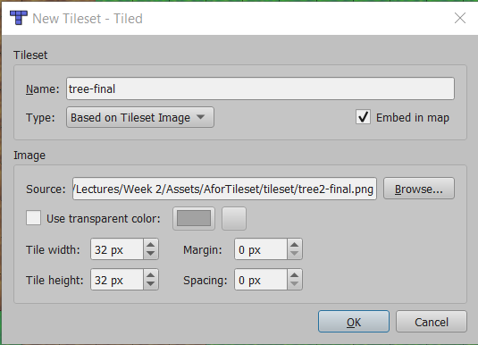
3. Click OK.
4. At the tileset select the base of the tree, as shown below:  
     
   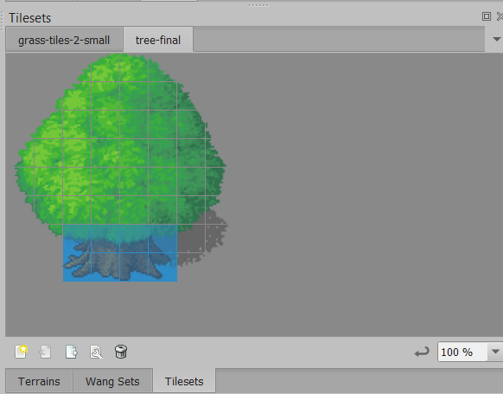
5. Under the Layers menu, right-click 🡪 New Tile layer.
6. Double-click on the existing tile layer and change its name to Background.
7. Double-click on the new tile layer and change its name to Foreground (the one with the tree base).   
   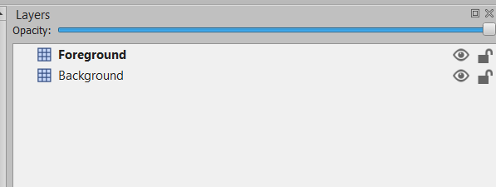
8. Click on the map and add the tree base.  
     
   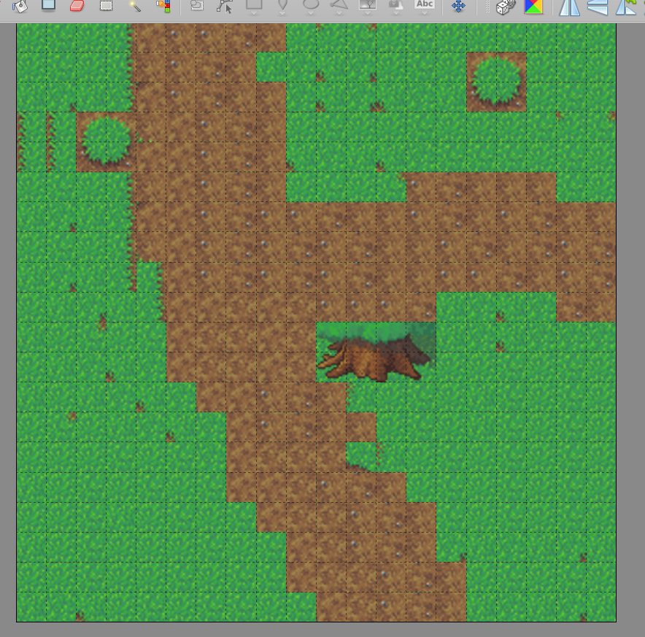
9. Right-click on the Layers menu New 🡪 Tile Layer.
10. Name it Top.
11. Select the rest of the tree and place it over the bottom.  
      
    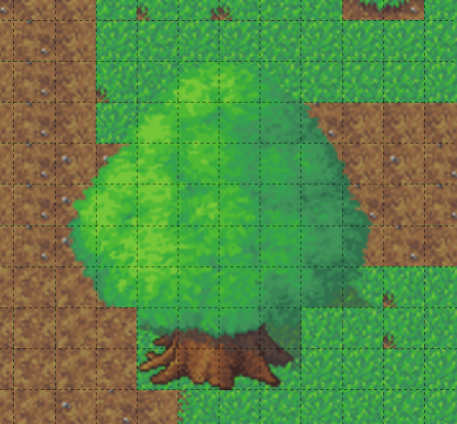
12. Click on the Save button at the top menu.  
      
    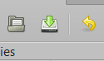

Once you complete the previous steps:

|  |
| --- |
| **TASK 2.1:**  Take a screenshot of the Tiled screen and paste it below: |
|  |

# ACTIVITY 3

## COLLISIONS

This activity demonstrates how to add Collision properties to map objects. Collissions add physical barriers, allowing them to interact with or to restrict the movement of characters and other objects.

Follow the steps below:

1. Click on the Edit Tileset button under the Tilesets menu.  
     
   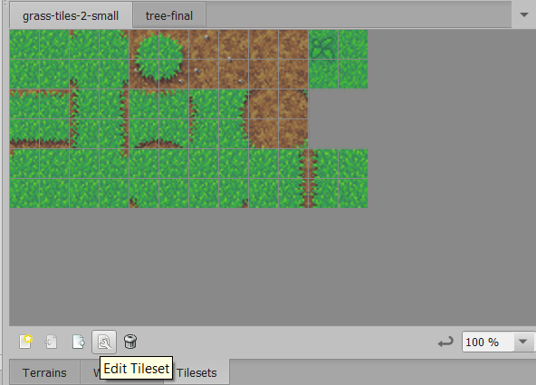
2. In the new window select the area, you want to add a collision to, and click on the Tile Collision Editor button.  
     
   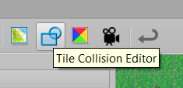
3. Under the Tile Collision Editor window, set the zoom to a lower level (200%).
4. Select the Polygon tool and draw a Colission around the circle as shown below.  
     
   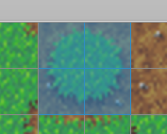  
     
   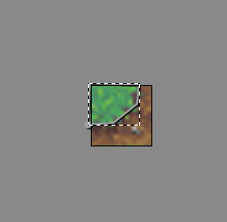
5. Repeat the previous step to all the consisting tiles.
6. Click the Save button.
7. Return to the map.

Once you complete the previous steps:

|  |
| --- |
| **TASK 3.1:**  Take a screenshot of the Tiled screen and paste it below: |
|  |

|  |
| --- |
| **TASK 3.2:**  Locate the MyMap1.tmx file and add it to the submission folder. |
| upload iconIn the LMS, add the file to the assignment Lab #2 submission folder. You can submit multiple files at a time. |

|  |
| --- |
| **TASK 3.3:**  What is the difference from before? Answer the question in the cell below. |
| * A new window got opened that says NewMap.tmx#grass-tiles-2-small * And now there should be collision for the bushes |

1. Save the map, pressing the Save button.

# ACTIVITY 4

## ANIMATIONS

Animations in Tiled are Tiles projects serially to create a motion. In this example, we are adding a few consecutive tiles for animating the a part of the map.

Follow the steps below:

1. Download the objects Tileset under Quiz1.2 from E-Centennial and save it to your computer.
2. Return to the Tiled and under the Tileset menu, click on the **New Tileset** button.
3. Configure the settings as shown below:  
     
   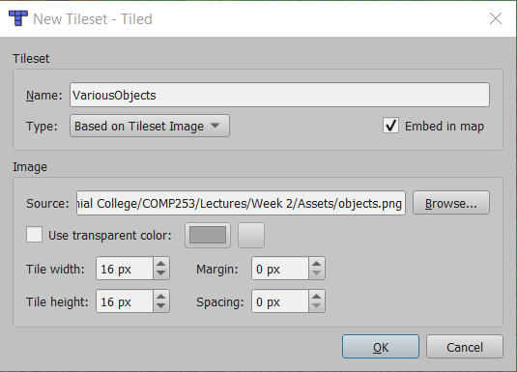
4. Click on the **Edit Tileset** button.
5. Click on one of the fireplace tiles.
6. In the new windows click on the **Tile Animation** Editor button.  
     
   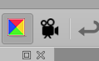
7. Double-click on a few of the fireplace icons, so that they create an animation timeline.
8. Modify the Frame Duration of the individual frames to create a smooth transition.
9. Click Apply.
10. Click Close.
11. In the tileset window click Save.
12. Return to the map window.
13. Under the Tilesets menu click on the fire tile with the animation icon.  
      
    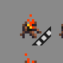
14. Click in the map and add the animated tiles.

|  |
| --- |
| **TASK 4.1:**  Take a screenshot of the Tiled screen and paste it below: |
|  |

|  |
| --- |
| **TASK 4.2:**  What is the difference from before? Answer the question in the cell below. |
| The fireplace is now animated but very small that you can barely see it.  The height is 16 and the width is 16 still. |

# ACTIVITY 5

## TERRAIN

This activity demonstrates how to create a terrain using the Tiled utility.

Follow the steps below:

1. Download the tileset_farm Tileset under Quiz1.2 from E-Centennial and save it to your computer.
2. In the Tiled select File 🡪 New 🡪 New Map.
3. Set the size to 50 and the pixels to 32.
4. In the new map click New Tileset.
5. Select the tileset_farm tileset and save it.
6. Select any green tile from the Tileset menu and click on the Bucket Fill Tool  
     
   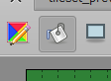
7. Click on the Terrain and fill all the Tiles with green color.
8. At the Tilesets menu click on the Edit Tileset button.
9. Click the **Terrains** button.
10. At the lower – right corner click the + symbol.
11. Double – click on the new item and rename it Hay.
12. Select four squared-shaped Hay tiles from the Tileset, press right – click and select Set Terrain Image.
13. Repeat steps 10 – 12 but name the new Terrain Water and pick water tiles.
14. Repeat steps 10 – 13 but name the new Terrain Strawberries and pick strawberry tiles.
15. Return to the map.
16. Click on the Terrains tab at the bottom – right corner.
17. Select the Terrains and paint a farm map.

Once you complete the previous steps:

|  |
| --- |
| **TASK 5.1:**  Take a screenshot of the Tiled screen and paste it below: |
|    * I am confused with this whole part |

|  |
| --- |
| **TASK 5.2:**  Export the Map as an image named Terrain and add it to the submission folder. |
| upload iconIn the LMS, add the file to the assignment Lab #2 submission folder. You can submit multiple files at a time. |

# ACTIVITY 6

## IMPORTING TILESETS TO UNITY

The first step is to export the Tilemap as a png image file. Then we import the file and configute the settings. The new tilemap can be then used as background, map or texture.

Follow the steps below:

1. In the Tiled editor click File 🡪 Export as Image.
2. Name the image MyMap.png and press Export.
3. Open the Unity Hub, double – clicking on the Unity icon.
4. Create a new 2D project with the name TiledTutorial and store to your computer.
5. Under the Project menu, right – click on the Assets folder and select Create 🡪 Folder.
6. Name the new folder Levels.
7. Drag and drop the MyMap.png file into the Levels folder.
8. Click on the MyMap tileset and under the Inspector configure the settings as shown below:  
     
   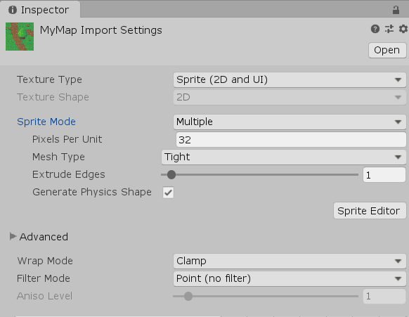
9. Under scroll down and under the Default tab set the Compression to None.
10. Click Apply.
11. If asked verify the application.
12. Under the Sprite Editor click on Slice.
13. Set the settings as shown below:  
      
    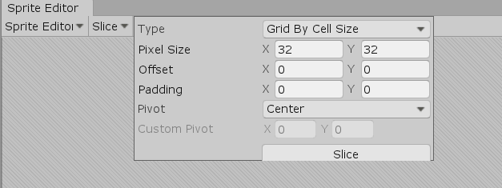
14. Click Slice.
15. Click Apply.

|  |
| --- |
| **TASK 6.1:**  Take a screenshot of the Unity Levels folder and paste it below: |
|  |

1. Right – click in the Hierarchy menu 🡪 2D object 🡪 Tilemap.
2. Click on the resulting Grid item.
3. Expand the Grid and reveal the Tilemap.
4. Click on the Tilemap.
5. Select Window 🡪 2D 🡪 Tile Palette.
6. Click on the **Create New Palette** button.
7. Set the options as shown below:  
     
   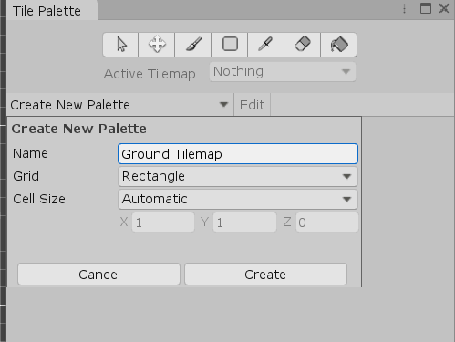
8. Click Create.
9. Create a new folder under the Assets and name it, Palettes.
10. Click Select Folder.
11. Select the parent Tile from the Project menu and drop it to the Palette menu.
12. When asked for a folder under the Assets create a folder named Tiles and inide this folder a subfolder named Ground Tiles.
13. Click Select Folder (the next step takes a while).

Once you complete the previous steps:

|  |
| --- |
| **TASK 6.2:**  Take a screenshot of the Unity Tile Palette window and paste it below: |
|  |

1. Click on the Paint with active brush button and select parts of the Active Tilemap and draw an entire new level at your Tilemap in the Scene View.

|  |
| --- |
| **TASK 6.3:**  Take a screenshot of the Unity Game Engine Scene View and paste it below: |
|  |

FINAL STEP: Save this document as a PDF. Upload the PDF to the Lab #2 submission folder.